“Spring Data JPA - Quick Example”
Hands On 1
1.Country.java
package com.cognizant.orm_learn.model; // ✅ Must match your folder structure exactly
import jakarta.persistence.Column;
import jakarta.persistence.Entity;
import jakarta.persistence.Id;
import jakarta.persistence.Table;
@Entity
@Table(name = "country") // ✅ This must match your DB table name
public class Country {
@Id
@Column(name = "co_code") // ✅ Match DB column name
private String code;
@Column(name = "co_name")
private String name;
// ✅ Getters and Setters
public String getCode() {
return code;
}
public void setCode(String code) {
this.code = code;
}
public String getName() {
return name;
}
public void setName(String name) {
this.name = name;
}
// ✅ toString
@Override
public String toString() {
return "Country [code=" + code + ", name=" + name + "]";
}
}

2.CountryService.java
package com.cognizant.orm_learn.service;
import java.util.List;
import org.springframework.beans.factory.annotation.Autowired;
import org.springframework.stereotype.Service;
import org.springframework.transaction.annotation.Transactional;
import com.cognizant.orm_learn.model.Country;
import com.cognizant.orm_learn.repository.CountryRepository;
@Service
public class CountryService {
@Autowired
private CountryRepository countryRepository;
@Transactional
public List<Country> getAllCountries() {
return countryRepository.findAll();
}
}

3.CountryRepository.java
package com.cognizant.orm_learn.repository;
import org.springframework.data.jpa.repository.JpaRepository;
import org.springframework.stereotype.Repository;
import com.cognizant.orm_learn.model.Country;
@Repository
public interface CountryRepository extends JpaRepository<Country, String> {
}
4.OrmLearnApplication.java
package com.cognizant.orm_learn;
import java.util.List;
import org.slf4j.Logger;
import org.slf4j.LoggerFactory;
import org.springframework.boot.SpringApplication;
import org.springframework.boot.autoconfigure.SpringBootApplication;
import org.springframework.context.ApplicationContext;
import com.cognizant.orm_learn.model.Country;
import com.cognizant.orm_learn.service.CountryService;
@SpringBootApplication
public class OrmLearnApplication {
private static final Logger LOGGER = LoggerFactory.getLogger(OrmLearnApplication.class);
private static CountryService countryService;
public static void main(String[] args) {
ApplicationContext context = SpringApplication.run(OrmLearnApplication.class, args);
countryService = context.getBean(CountryService.class);
testGetAllCountries();
}
private static void testGetAllCountries() {
LOGGER.info("Start");
List<Country> countries = countryService.getAllCountries();
LOGGER.debug("countries={}", countries);
LOGGER.info("End");
}
}
5.application.properties
# Spring Framework and application log
logging.level.org.springframework=info
logging.level.com.cognizant=debug
# Hibernate logs for displaying executed SQL, input and output
logging.level.org.hibernate.SQL=trace
logging.level.org.hibernate.type.descriptor.sql=trace
# Log pattern
logging.pattern.console=%d{dd-MM-yy} %d{HH:mm:ss.SSS} %-20.20thread %5p %-25.25logger{25} %25M %4L %m%n
# Database configuration
spring.datasource.driver-class-name=com.mysql.cj.jdbc.Driver
spring.datasource.url=jdbc:mysql://localhost:3306/ormlearn
spring.datasource.username=root
spring.datasource.password=Gun@Strong#DB84
# Hibernate configuration
spring.jpa.hibernate.ddl-auto=validate
spring.jpa.properties.hibernate.dialect=org.hibernate.dialect.MySQL8Dialect

1.SPRING INITIALIZR
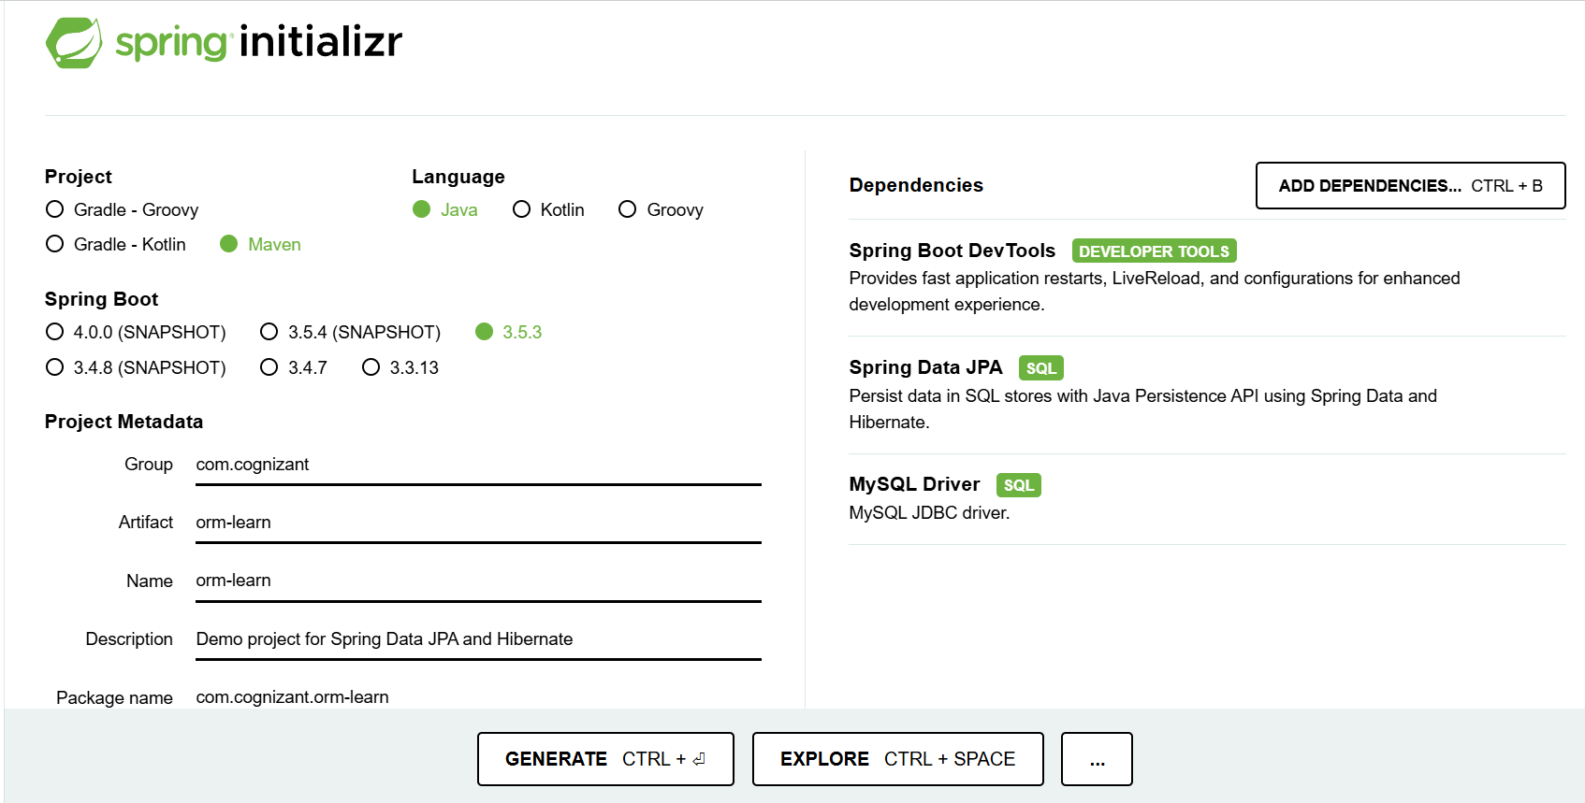

2.MAIN METHOD()
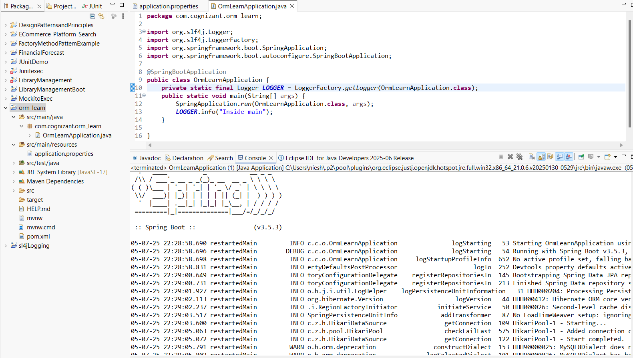

3.SQL CONNECTION
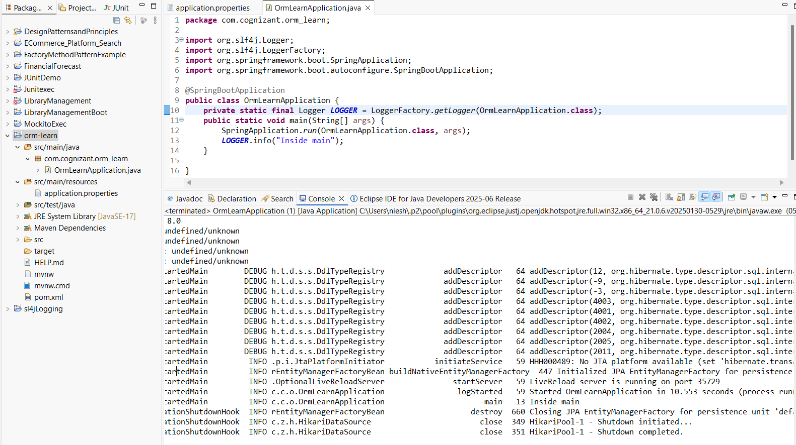

4.COMMAND EXECUTED
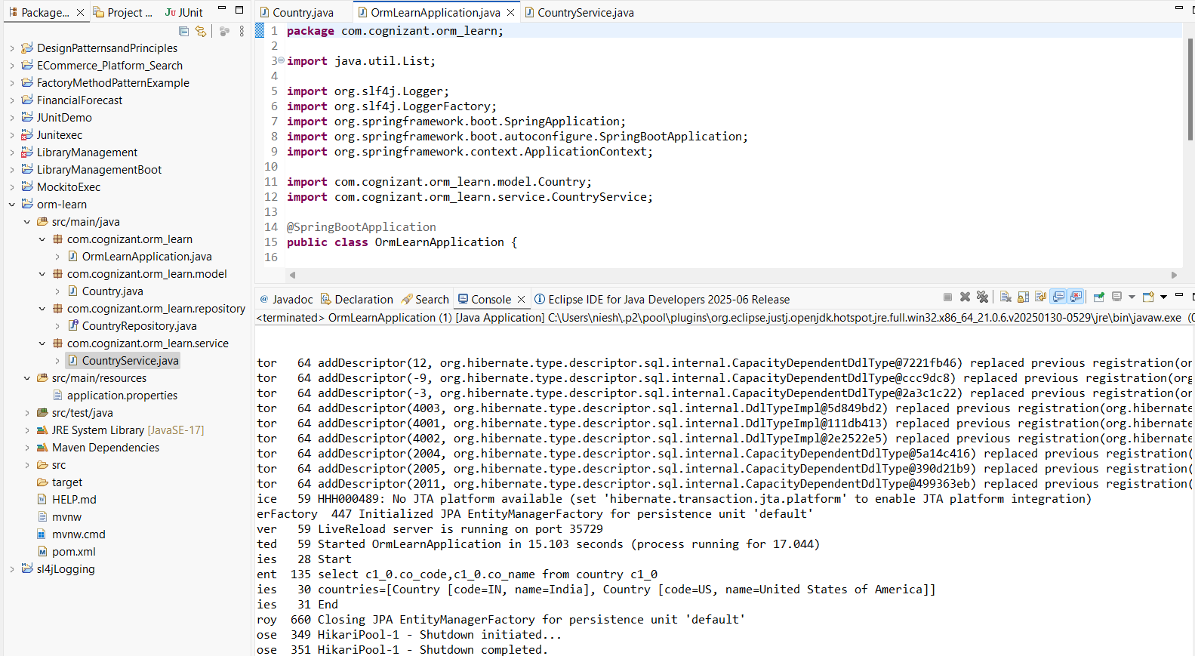
---------------------------------------------------------------------------------------------------------------------------
Hands-on 4: Difference between JPA, Hibernate and Spring Data JPA
1. Java Persistence API (JPA)
- JPA is a Java specification (JSR 338) that defines how to manage relational data using Java objects.
- It provides standard interfaces and annotations for object-relational mapping (ORM) but does not provide any implementation.
- It acts as a bridge between Java applications and the database, offering a standard way to perform CRUD operations.
- Examples of JPA annotations: @Entity, @Table, @Id, @Column.
- Popular JPA implementations include Hibernate, EclipseLink, and TopLink.

2. Hibernate
- Hibernate is a concrete ORM tool and the most widely used implementation of JPA.
- It provides additional features beyond JPA like caching, lazy loading, batch processing, and custom SQL execution.
- Hibernate allows developers to directly interact with the Session API, giving fine-grained control over transactions and database interactions.
- Requires more boilerplate code compared to Spring Data JPA.
3. Spring Data JPA
- Spring Data JPA is a Spring-based abstraction over JPA that reduces boilerplate code.
- It simplifies JPA-based data access layers by providing predefined repository interfaces like JpaRepository, CrudRepository, etc.
- It is not a JPA implementation itself, but it works on top of a JPA provider like Hibernate.
- Spring Data JPA handles the infrastructure and transaction management automatically using annotations like @Transactional and @Repository.

Code Comparison
1.Using Hibernate (Manual Transaction Management)
public Integer addEmployee(Employee employee) {
Session session = factory.openSession();
Transaction tx = null;
Integer employeeID = null;

try {
tx = session.beginTransaction();
employeeID = (Integer) session.save(employee);
tx.commit();
} catch (HibernateException e) {
if (tx != null) tx.rollback();
e.printStackTrace();
} finally {
session.close();
}
return employeeID;
}

2. Using Spring Data JPA (Simplified Approach)
public interface EmployeeRepository extends JpaRepository<Employee, Integer> {
}
@Service
public class EmployeeService {

@Autowired
private EmployeeRepository employeeRepository;

@Transactional
public void addEmployee(Employee employee) {
employeeRepository.save(employee);
}
}
---------------------------------------------------------------------------------------------------------------------------

